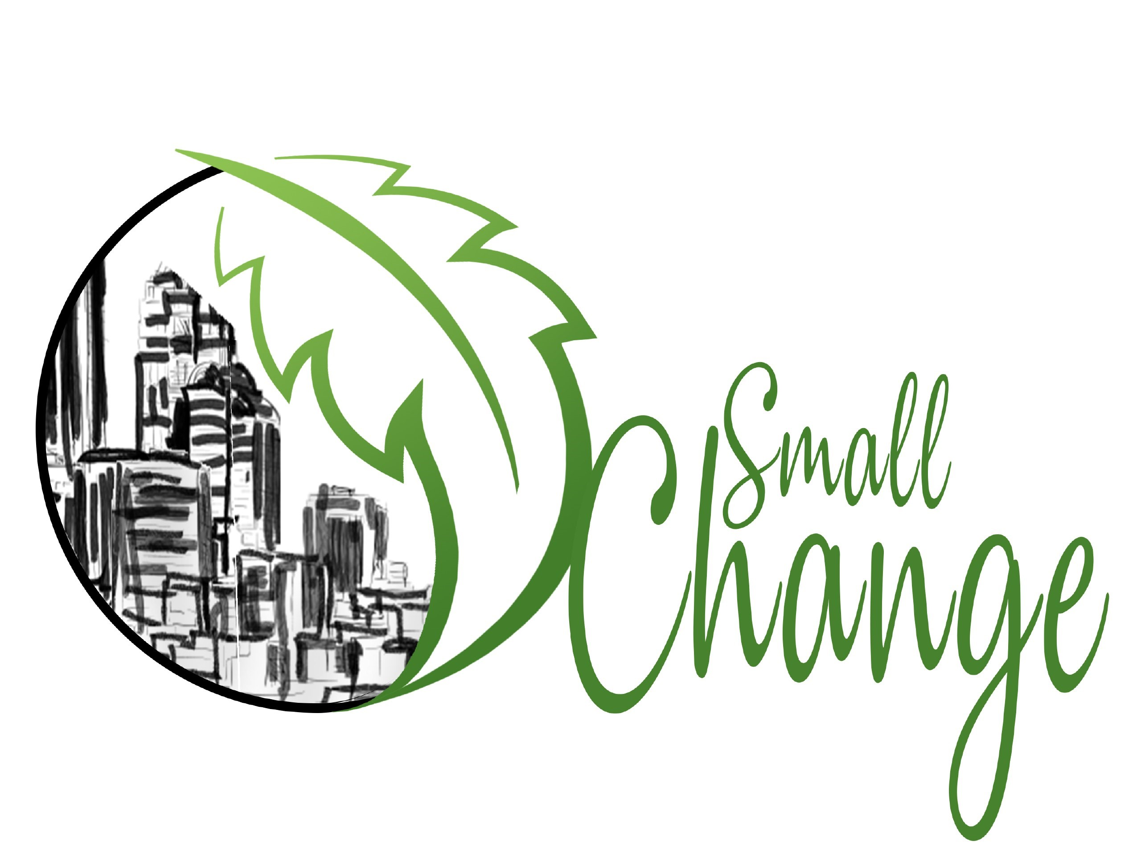
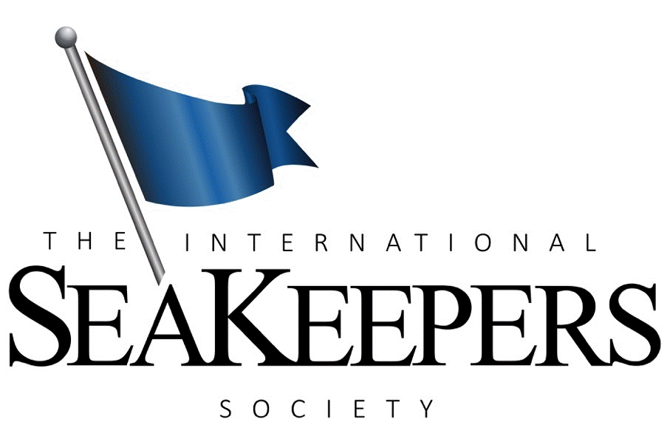
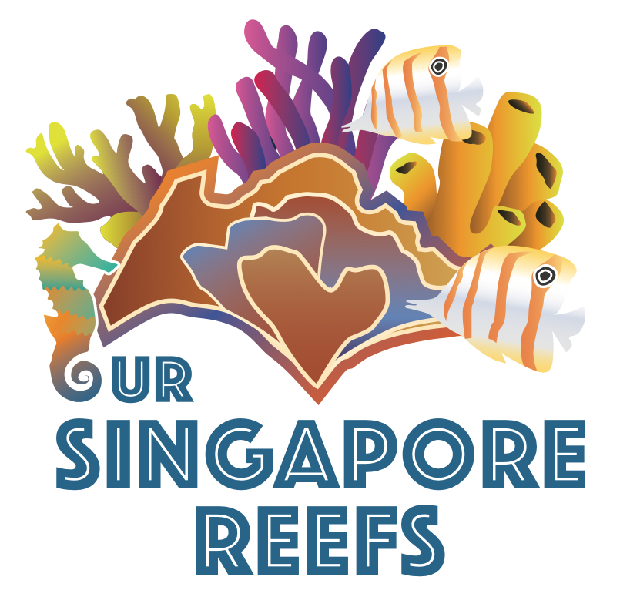
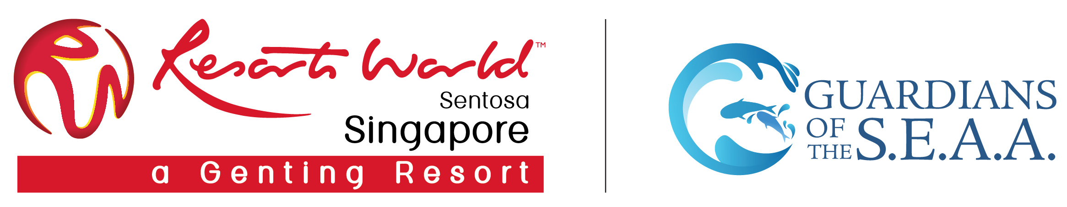

PRESS RELEASE
For Immediate Release

Local Marine Conservation Groups Join Hands for
Singapore’s Largest Coordinated Underwater Cleanup

- International SeaKeepers Society Asia, Our Singapore Reefs, Resorts World Sentosa’s Guardians of the S.E.A.A. and Small Change rally together for a reef cleanup to mark World Oceans Day
- Combined team of 65 dive volunteers recovered over 1,800 pieces of marine debris weighing 127kg within four hours

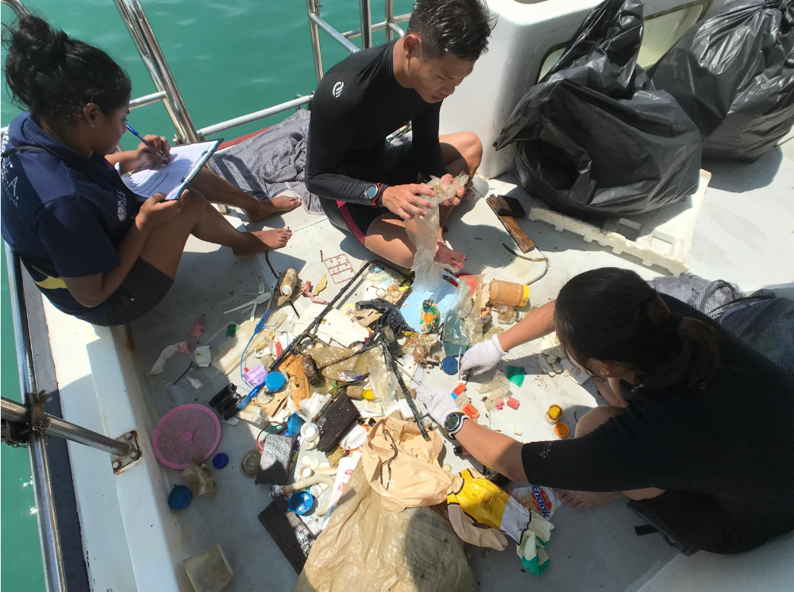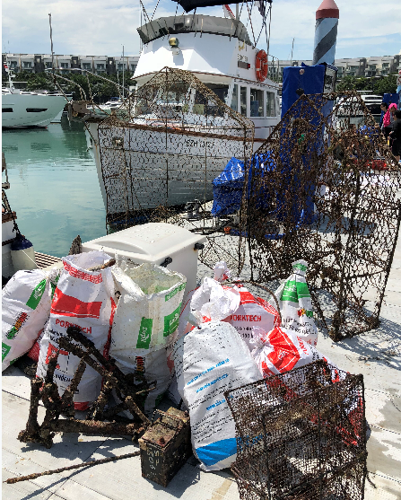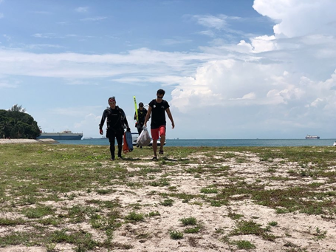
A total of 65 dive volunteers from International SeaKeepers Society Asia, Our Singapore Reefs, Resorts World Sentosa’s Guardians of the S.E.A.A. and Small Change rallied together on 9 June for Singapore’s largest coordinated reef cleanup. The teams recovered 1,887 pieces of marine debris weighing 127.5 kg.

SINGAPORE, 27 June 2019 – Many hands make light work, which was evident when four locally-based marine conservation groups joined hands for Singapore’s largest coordinated reef cleanup earlier this month on 9 June. The underwater cleanup was organised to commemorate World Oceans Day – a global celebration with worldwide events celebrating the ocean and creating awareness on the need for marine conservation.

A total of 65 dive volunteers comprising scientists, researchers, S.E.A. Aquarium aquarists and marine enthusiasts, covered various locations around Lazarus Island. The underwater cleanup is the first of its kind that involved three non-profit marine conservation groups – Our Singapore Reefs, International SeaKeepers Society Asia and Small Change – working alongside Resorts World Sentosa’s conservation group Guardians of the S.E.A.A., with support from scuba group The Submersibles and Project Aware.

On mission day, the divers were organised into smaller groups each led by experienced dive guides from Our Singapore Reefs, Resorts World Sentosa’s Guardians of the S.E.A.A., Small Change and The Submersibles. They were transported to 3 dive locations in five boats. The teams recovered 1,887 pieces of marine debris weighing 127.5 kg within half a day. The top five category of items collected were plastic cutlery, styrofoam packaging, plastic bottles, plastic caps and lids, as well as fishing lines and nets. Worldwide, marine pollution have been known to harm both wildlife and human alike.

Lazarus Island is an uninhabited island and part of Singapore’s Southern Islands. Underwater cleanups are a practical way to maintain the beauty and cleanliness of the water as well as the coral reefs in the area. Part of the challenges in removing underwater trash include poor visibility due to silt-out – a condition where sediments fill the water column – and strong currents, all of which meant the underwater exercise had to be executed by experienced divers only.

Dr Toh Tai Chong, Our Singapore Reefs, said: “This collaboration aims to raise the profile of World Ocean Day in Singapore and with the help from the community, we are committed to reducing the amount of marine debris in our oceans".

SeaKeepers volunteer Gabor Bati said: “I have had an amazing time with the team. Unfortunately the low visibility hampered our removal of more underwater trash. However, the amount of surface trash caught in the breakwater was overwhelming and sadly we were unable to reach every spot. I think there is definitely more for us to do.”

Lim Teck Koon of Small Change added: “The bay at (Seringat Bay / Eagle Bay) Lazarus is a popular parking spot for party boats - on weekends, there can be up to 16 boats in the bay. While the bay looks like a white sandy paradise at high tide, low-tide exposes a "colorful" inter-tidal and sub-littoral zones littered with marine debris trapped by seaweed and sea-grass. It is no surprise that the debris with the highest count found here are plastic cups / mineral water cups that deposit in piles underwater due to the underwater topography of the bay. Though many may argue that the effort and carbon foot print of such a clean up event is not worth the amount of trash removed, we believe such events are still necessary not only to create awareness and educate the public, but also because the trash should not be allow to stay and pollute our ocean.”

All debris recovered was transported to One°15 Marina and Resorts World Sentosa for proper disposal. The data collected on the types, sources and location of marine debris will be reported to Project AWARE’s Dive Against Debris®, a citizen-science programme that contributes to the global effort to combat marine debris.

-END-

MEDIA CONTACTS
Our Singapore Reefs
Dr Toh Tai Chong, Co Founder +65 97960792 / oursingaporereefs@gmail.com

International SeaKeepers Society, Asia
Ms Gail Tay, Director of Operations & Programmes +60 128225832 / gail.tay@seakeepers.org

Resorts World Sentosa’s Guardians of the S.E.A.A.
Mr Shaiful Rizal, Senior Manager, Communications & CSR +65 6577 9761 / shaiful.malek@RWSentosa.com

Small Change
Mr Lim Teck Koon, Co-Founder / Programs & Outreach / Julian Mattias, Co-Founder / Communications
+65 96555879 / +65 94517542 / SmallChangeLastingImpact@gmail.com

IMAGES
- All images should be attributed to respective organisations in the image library.
- Images can be downloaded from https://www.dropbox.com/sh/d44c9yzvpibmpol/AACOuC9jI9Z2F3lA7y7faajva?dl=0

About Our Singapore Reefs
Our Singapore Reefs (OSR) is a community initiative that was established in May 2017 by a group of divers who love Singapore's coral reefs. The group aims to promote awareness about Singapore's marine biodiversity and provide a platform for academics, businesses, NGOs and agencies to work together for a common cause. This initiative will empower the public with means to conserve and protect Singapore's reefs and encourage them to be active citizens. For more information, please visit: www.facebook.com/oursingaporereefs and www.instagram.com/oursingaporereefs

About Resorts World Sentosa’s Guardians of the S.E.A.A. and S.E.A. Aquarium
Guardians of the S.E.A.A. is the conservation group of S.E.A. Aquarium at Resorts World Sentosa. The group takes greater strides in supporting conservation research, education and public engagement efforts by bringing together a community of like-minded people and organisations collaborating with S.E.A. Aquarium to protect the marine environment.

Opened in November 2012, S.E.A. Aquarium is one of the world’s largest aquariums home to more than 100,000 marine animals from across 1,000 species. Featuring more than 50 diverse habitats, S.E.A. Aquarium exhibits close to 80 threatened species including the manta ray, Clarion angelfish and a variety of beautiful corals that mirror a pristine aquatic environment. Through interactive programmes, up-close animal encounters and immersive learning journeys, S.E.A. Aquarium aims to inspire visitors to protect the world’s oceans. For more information, please visit www.rwsentosa.com and www.facebook.com/groups/GuardiansoftheSEAA/

About The International SeaKeepers Society
The International SeaKeepers Society is a non-profit organization focusing on the health of the world’s oceans and climate. SeaKeepers works with the boating and yachting community to take advantage of their unique potential in order to further marine research and to raise awareness about the issues our oceans face. The International SeaKeepers Society acts as a global catalyst working with governments, scientists, industry, and other marine organizations to further its mission and to support sensible, achievable marine protection and restoration. The International SeaKeepers Society established SeaKeepers Asia in 2016. For more information, please visit: www.seakeepers.org and www.facebook.com/seakeepers

About Small Change
With the Mission - "To inspire a global movement of SUSTAINABLE Small Change everyone can make in our daily lives to create a lasting positive impact on the Environment." Small Change started as just a Facebook Page in April 2017, gathering and sharing posts on positive action and small sustainable changes in lifestyles. In an effort to reach more people, Small Change organized their first Dive and Beach Clean-up event in Oct 2017 and since then, the team has grown and expanded to running more outreach and educational programs and events including school engagements and corporate CSR Programs. For more information, please visit: www.facebook.com/SmallChangeLastingImpact/ and www.instagram.com/smallchangelastingimpact/

About The Submersibles
The Submersibles was started in 2006 with the aim of providing a one-stop solution for recreational scuba divers. She has since grown into a PADI 5 Star Dive Center, providing high quality Scuba Diving education, offer a wide range of retail items for divers, organize diving at exotic dive sites across the region as well as promote local diving at Pulau Hantu. For more information,please visit: www.facebook.com/submersibles and www.thesubmersibles.com

About Project Aware and Dive Against Debris®
Project AWARE’s is a registered non profit organisation.Its flagship citizen-science program, Dive Against Debris®, empowers scuba divers to remove marine debris from the ocean and report data on the types, quantities and locations of materials collected. Since the program’s launch in 2011, more than 50,000 divers have participated in Dive Against Debris in 114 countries around the world, reporting over 1 million pieces of trash. As the only underwater debris data collection program of its kind, Dive Against Debris both improves the health of ocean ecosystems through localized volunteer efforts and provides valuable information about underwater debris to help inform policy change. For more information , please visit: www.projectaware.org/

